7 Ways to Make Your Offers Hard to Refuse

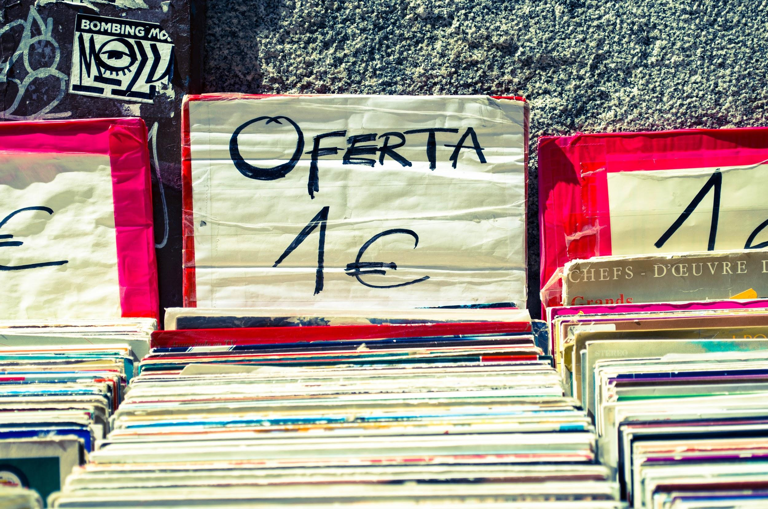

You’ve got a product or service to sell, but it’s not going to sell itself. In this post, I’m going to give you some tips on how to make your offers so irresistible that your audience just HAS to buy! After all, as the saying goes, “nothing happens until someone sells something”! Let’s get those sales numbers up then, shall we?

### #1 A Money-Back Guarantee

Back up your product or service with a guarantee of some sort. Whether you offer your customers a limited time guarantee for them to try your product or service with no risk, or whether you offer a “forever” guarantee (be careful: this can be hard to maintain), you’re still showing them that you believe in what you’re selling. Plus, since the risk is lower, customers may be willing to make a purchase that they otherwise wouldn’t.

### #2 A Free Trial

Market your service by letting customers get a taste of what you do for free (for a limited time, of course). Think about how many more customers you might attain if you simply allowed them to try your business out with zero risks. Once they’ve tried it, your chances of gaining them as a customer most certainly increase.

You may be thinking, *But I sell a product. Doesn’t a free trial work best with a subscription service?* Well, not these days. I’ve seen product commercials that offer items like mattresses or make-up for free for a limited period. You can offer a trial version of just about any product.

### #3 Premiums

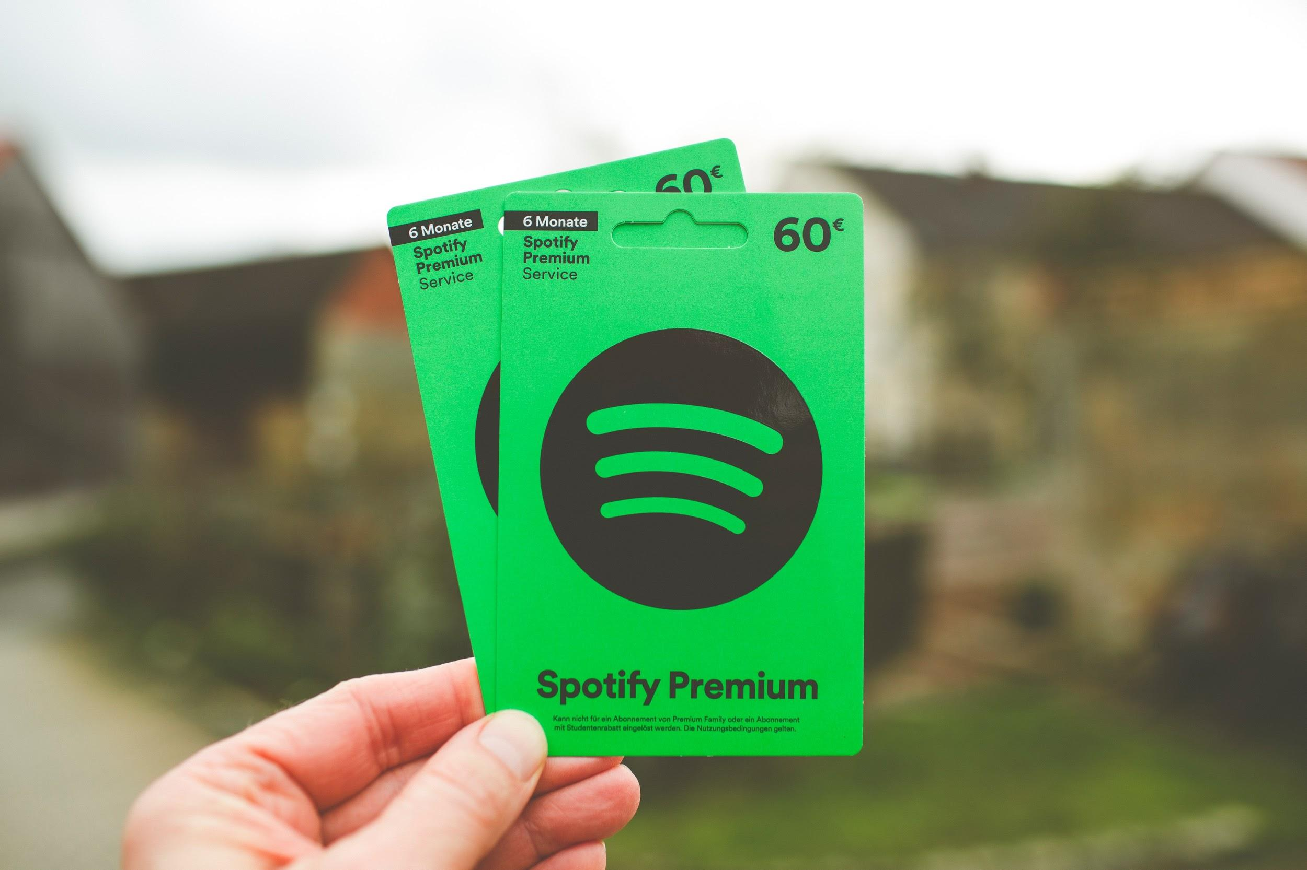

Are you old enough to remember the football phone that came with your subscription to Sports Illustrated? Well, that football phone is what’s known as a ‘premium’. Use other products that have high perceived value with your audience to enhance the attractiveness of your own by including them for free with their purchase.

### #4 Free Shipping

People like free, and free shipping will get your online buyers to do a double-take. In fact, they do more than a double-take, they’ll actually increase their orders, too.

You don’t have to offer free shipping on all purchases, but you should always have a targeted revenue amount that if your customer hits, the order will be shipped for free (Example: Spend $100 and shipping is on us!). Know your numbers and this is a win for everyone!

### #5 A Challenge



Want to market yourself and make sales at the same time? Then, it’s challenge time! Everyone loves a good challenge, and your audience will naturally spread the word (especially if they win!). Restaurant? Wing-eating or colossal burger eating challenge. Selling make-up? Best makeover challenge. Carpet cleaner? Most jaw-dropping before and after pic of a messy room. You name it, you can make a challenge out of it. Then, award the winner with some of your products or services for free!

### #6 Insane DoorBuster Deals

Use the DoorBuster method when you’ve got a great deal to offer or just need to spice up your monthly sales numbers. Entice customers by offering free products or services to the first 10, 20, or 30 people to fill out a form on your website, come to your brick and mortar store, or message you with a code word. Need to market a particular product? Offer it at half-off one day per month.

But remember, don’t offer what you can’t afford. And another word of caution: don’t use this all the time. Otherwise, you could appear too desperate.

### #7 BOGO Deals

Again, people love “free.” If you’ve got some product to offload, or if you’re trying to get your services marketed to a wider audience, then consider offering a BOGO deal for your customers. If they buy a pair of shoes, give them one free. If they buy five body soaps, give them 5 free. Whatever it is, just know your numbers, and make sure that you tell them that this BOGO sale won’t last forever.

## Last-Minute Tips for Conveying Value to Customers

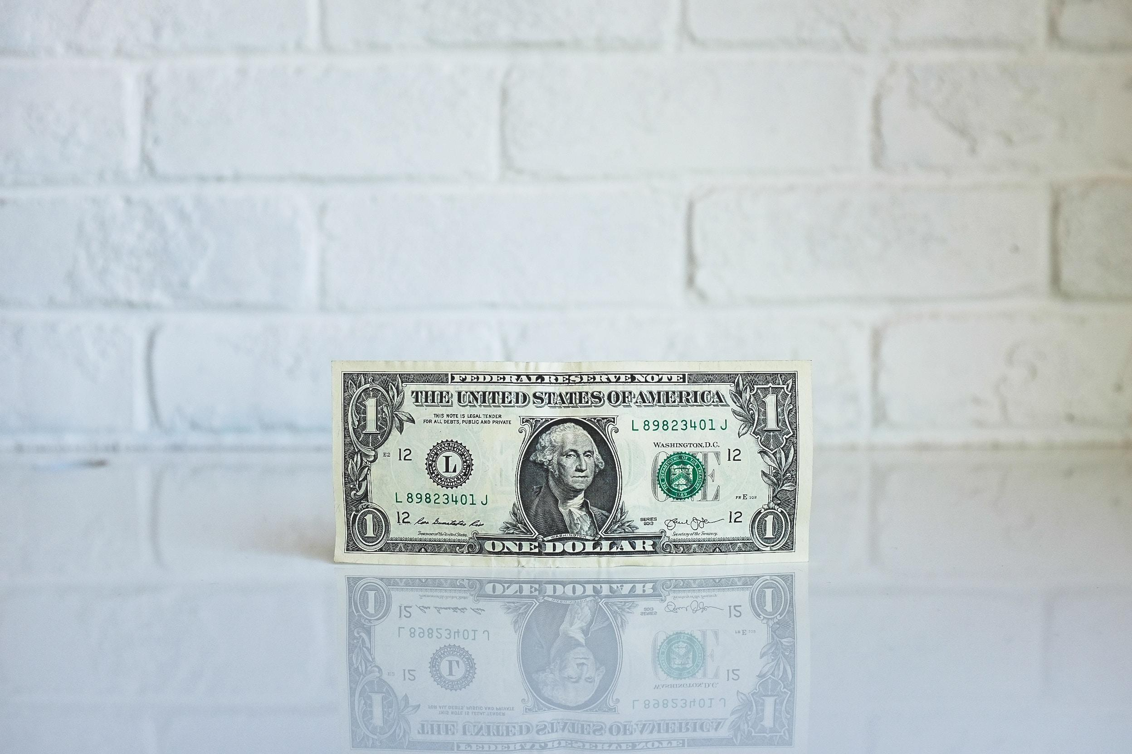

When marketing these deals, keep the following ideas in the forefront of your approach: scarcity, limited time, exclusivity, and value. Your customers need to know that you’ve got a limited supply, that your sale won’t last forever, that your offer is geared specifically for them, and that your products or services have value. When customers sense that they have limited time to act and that what you’re selling will make their lives easier, they’ll jump on the deal.

________________________________________________________________

**Meta:** Here are some guaranteed ways to make what you are offering so irresistible to your customers. Use these seven ways to convey the value of what your offer brings to the people.

**Keywords:** marketing, value, customers, deals, free, offers

## 